Creating a pull request (solent6Public)

1. Go to the solent6Public GitHub Repo <https://github.com/gallenc/solent6Public>
2. Click on the pull request tab in the top menu

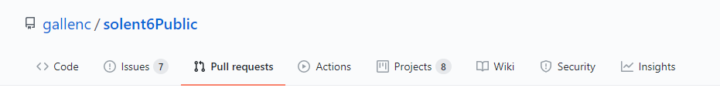

1. Click new pull request

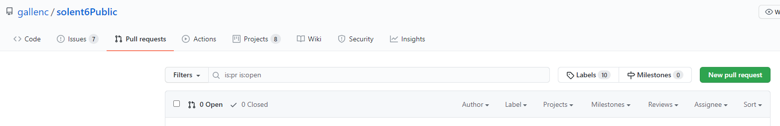

1. Select the devel branch as the base

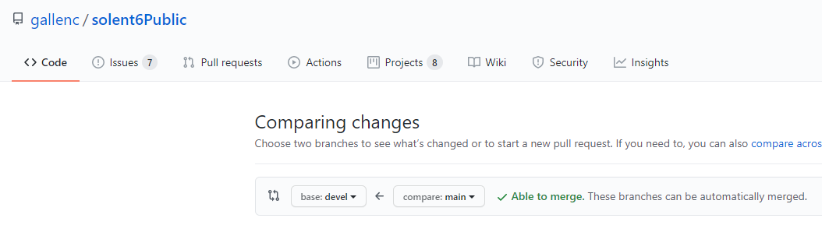

1. Select the branch you have been working on as the compare

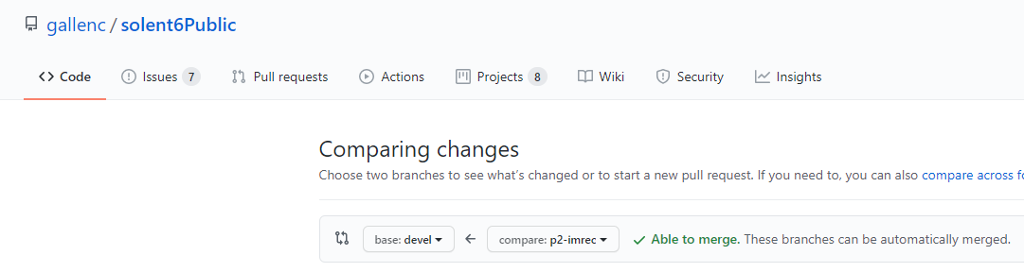

1. Then click create pull request

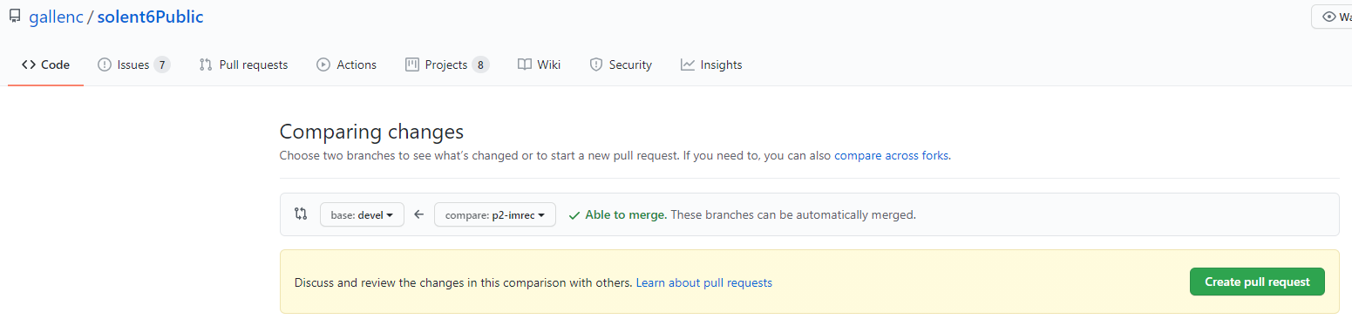

1. You will then see a screen that looks something like this

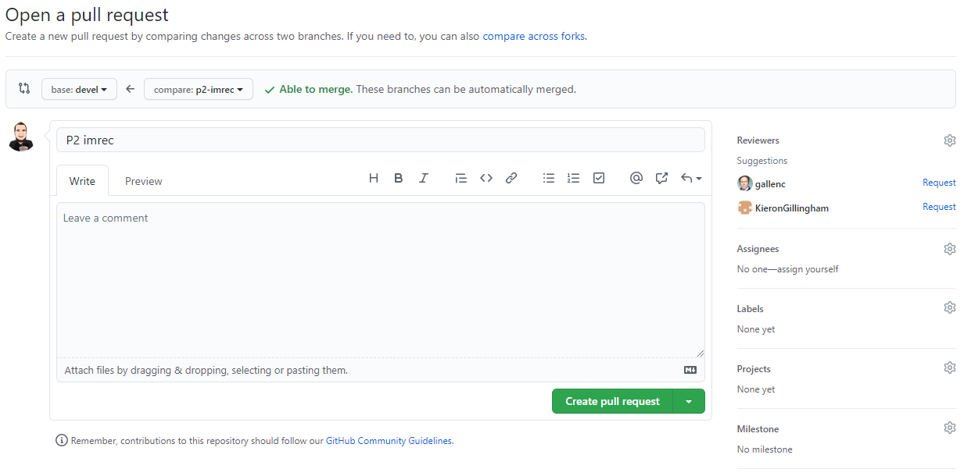

1. Now add the following reviewers to the pull request. All members of your team, a member of the DevOps Team, and a member of the team upstream and downstream from your team. In the case of P2 we would add a member of P1 and P3. Once you have done that you screen should look something like this. (Click on the cog to add these)

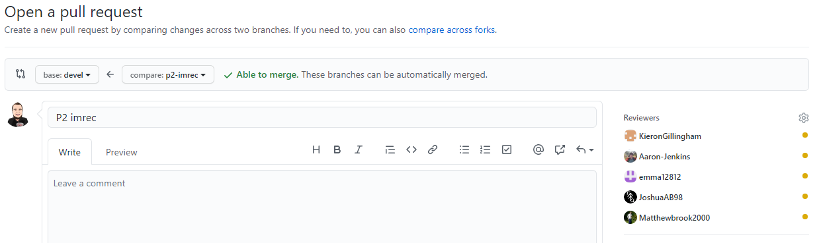

1. Now add assignees to the pull request. This should be every member of your team, so in the case of P2 that would be Matthew, Kieron, and Emma. Once do your screen will look something like this. (Click on the cog to add these)

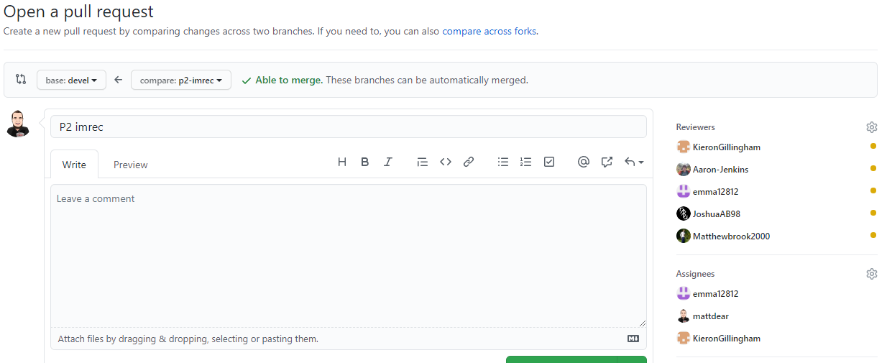

1. Now add labels to the pull request. For P2 this would be the P2 label and enhancement label. (Click on the cog to add these)

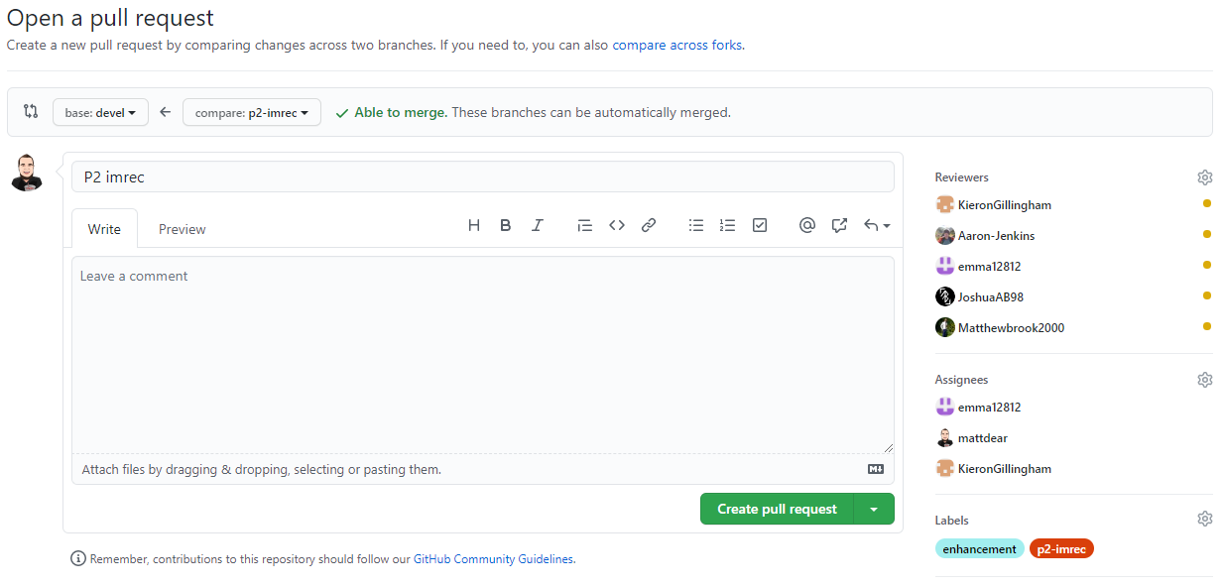

1. Now add the project to the pull request. For P2 it will be p2 Image Recognition. (Click on the cog to add these)

